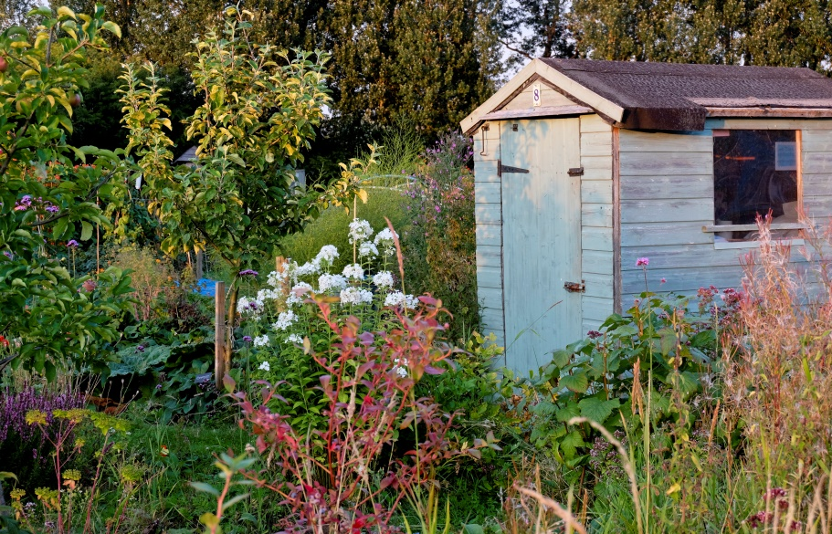
The Benefits
- Grow your own fresh, seasonal and delicious fruit and veg.
- If grown organically, your produce is chemical free.
- Enjoy a sense of achievement – it’s a great feeling when you harvest your own produce!
- Improve your health through regular exercise. It is a great way to relax and unwind.
- Environmental benefits – Allotments are great for biodiversity and by growing food locally we can help reduce food miles and the impact on climate change.
Where are Ginhall Lane Allotments?
- They are on the North West edge of Leominster, just over a mile from the town centre – about 20 minutes walk or a 5 minute cycle ride. There is no public transport but plenty of car parking on site.
Plot Size
- Full size plots measure approximately 250m2 , which is roughly equivalent to 20 car parking spaces.
- Mini plots are 3m x 1m.
General Health and Physical Ability
- A bonus of allotment gardening is that regular exercise and fresh air can benefit your health. Well-being is also enhanced when working with like-minded people in a beautiful setting. Gardening can be a strenuous activity so it is essential that you are realistic about any physical limitations and plan your gardening week accordingly. Working little and often may help avoid injuries and build stamina.
What to Grow
- A good starting point is to grow fruit and vegetables which you enjoy eating with your family and friends, then move on to try new and unusual varieties. There is always helpful advice on hand from other gardeners and you will be offered a ‘friendly mentor’ who will be able to give you support and encouragement during the initial months.

Tools and Equipment
- If you are a seasoned gardener, you will probably already have a set of tools at home, but if you are a new gardener you will need a few essentials such as a spade, fork, hoe, rake, hand fork, trowel and a watering can.
Time Required
- Allotment gardening can be a most enjoyable hobby but it is a continual process which requires commitment and regular attendance. A full size plot will require roughly 3-5 hours a week at peak times between March and September.
- Between October and February, the pace is much slower and it is a good time for clearing, weeding and digging, composting and manure application. There will still be the harvesting seasonal vegetables such as leeks, parsnips, sprouts, cabbage and kale.
Contact Details
If you would like to apply for an allotment, please contact Leominster Town Council on:
01568 611734 – Town Council Office
07587969691 – Environmental Services Supervisor
grounds@leominstertowncouncil.gov.uk

